

Economics

SAC 3.1 UNIT 3 OUTCOME 3

You will have 45 minutes to complete this task plus 5 minutes reading time

Teacher: Mr. Daniel Charles

The total SAC contributes to 30/100 of SAC marks allocated for Unit 3.

Allowed materials for this task include:
- Pens, pencils, rulers, erasers, highlighters

Name ____________________________________________

Note: The grade or score for this task is only part of the internal assessment for this Unit. Your total School-assessed Coursework score may change as a result of statistical moderation by VCAA.

Grade/Score: ______ Satisfactory Completion? S/N: ______
(Provisional)
VCE ECONOMICS
SCHOOL-ASSESSED COURSEWORK
Performance Descriptors
Unit 3  Outcome 3  Explain the factors that may influence Australia’s international transactions and evaluate how international transactions and trade liberalisation may influence the current account balance, the Australian Government’s domestic macroeconomic goals and living standards in Australia. | DESCRIPTOR: typical performance in each range
 | Very low | Low | Medium | High | Very high
 | Limited understanding of the factors that influence Australia’s transactions with the rest of the world. | Some understanding of the factors that influence Australia’s transactions with the rest of the world. | Satisfactory understanding of the factors that influence Australia’s transactions with the rest of the world. | Generally thorough understanding of the factors that influence Australia’s transactions with the rest of the world. | Sophisticated understanding  of the factors that influence Australia’s transactions with  the rest of the world.
 | Discussion demonstrates a limited understanding of the effects of international transactions and trade liberalisation on the current account balance, domestic macroeconomic goals and  living standards. | Some evaluation of the effects of international transactions and trade liberalisation on the current account balance, domestic macroeconomic goals and living standards. | Satisfactory evaluation of  the effects of international transactions and trade liberalisation on the current account balance, domestic macroeconomic goals and  living standards. | Well developed evaluation of  the effects of international transactions and trade liberalisation on the current account balance, domestic macroeconomic goals and  living standards. | Sophisticated evaluation of  the effects of international transactions and trade liberalisation on the current account balance, domestic macroeconomic goals and  living standards.
 | Limited use and application of economics terms, concepts, theories and data in the analysis and discussion. Little use of relevant data and evidence to support the explanation and discussion. | Some accurate application of knowledge and use of specialist economic terms, concepts and theories. Some reference to relevant data and evidence but not always applied appropriately. | Satisfactory selection, use and application of economics terms, concepts, theories, data and evidence to support the explanation and discussion. | Accurate definition, use and application of economics terms, concepts and theories. Sound use of relevant data and evidence to support the explanation and discussion. | Confident and accurate definition, use and application of economics terms, concepts and theories. Sophisticated use of relevant data and evidence to support the explanation and discussion.
 | Limited analysis and little understandings of international economic relationships. Reasoning and interpretation lacks clarity. Little evidence of an ability to synthesis arguments or draw appropriate conclusions. | Some understanding of international economic relationships with some relevant conclusions. Some use of relevant evidence, synthesis of arguments and logical economic reasoning. | Generally satisfactory analysis  of international economic relationships, issues and problems is demonstrated. Adequate ability to synthesis arguments and draw conclusions. | Generally thorough analysis  of international economic relationships, issues and problems is demonstrated. Economic reasoning and interpretation skills and an ability to synthesise arguments and draw conclusions are mostly well developed. | Comprehensive and logical analysis of international economic relationships, issues and problems is demonstrated. Sophisticated skills of economic reasoning and interpretation and an ability to synthesise arguments and draw conclusions are evident.

Section A –Short Answer Questions
Question 1
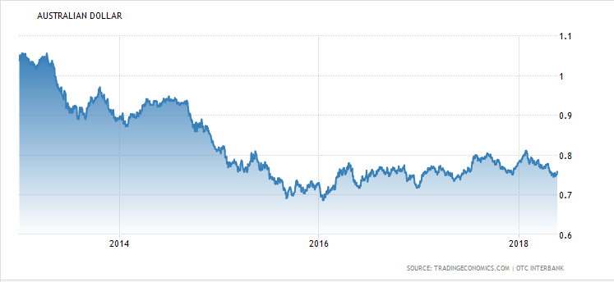
- Describe the trend in the exchange rate since 2016.
2 marks
The trend in the exchange rate since 2016 has been upward representing an overall appreciation of the $AUD against the $USD.

- Identify and explain one possible cause for the trend in the exchange rate since 2016
2 marks
One possible cause of the appreciation of the exchange rate since 2016 is an increase in demand for Australia’s exports. If overseas consumer demand more of Australia’s exports this will increase export revenue and therefore increasing the demand for the $AUD, appreciating its value.

- Explain the affect that the trend in the value of the $AUD since 2016 would have on one domestic macroeconomic goal
4 marks
The appreciation would have a negative impact on the goal of full employment, ceteris paribus. The appreciation. This would make Australian exports more expensive to foreign consumers, decreasing demand for exports and reducing export revenue (X). Furthermore, the appreciation would make imports cheaper for Australian consumers, increasing import expenditure, overall decreasing net exports (x-m) and reducing aggregate demand. A decrease in AD will mean firms reduce national production, decreasing the demand for labour and increasing cyclical unemployment, This will therefore have a negative effect on the goal of full employment, which is an absence of cyclical unemployment in the economy, while having the lowest unemployment rate possible without triggering inflation- the target of which is an unemployment rate of 4-4.5%.

Question 2
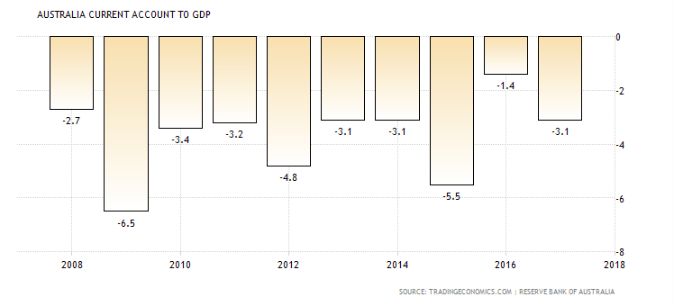

- Referring to the table above, explain what is meant by a current account deficit
2 marks
The table above signifies 10 years of current account deficits from 2008-2018, represented as the current account deficit as a percentage of GDP. This means that over the last 10 years, every year the value of debits in the net goods, net services, net primary income and net secondary income sections of the current account were greater than the value of credits.

- Australia has run a current account deficit for many years now, including 2017. Outline one structural cause and one possible cyclical cause for why this is the case.
4 marks

Structural cause
One structural cause for the persistent current account deficit is the savings-investment imbalance that the Australian economy has. Historically Australia has a low population with low savings, but a country and high level of investment spending. Due to the relative lack of savings available to firms, this requires many to borrow from overseas financial institutions, leading to a large volume of interest payments and therefore debits in the net primary income account, contributing to the ongoing current account deficit.

Possible cyclical cause
One possible cyclical cause for the current account deficit in 2017 is high consumer confidence. If households have a high level of optimism about their future financial situation, it means they will have a lower propensity to save their income, and a higher propensity to spend on imports and borrow money from overseas financial institutions. This will lead to an increase in debits in the balance of goods and services (BOGS) and net primary income sections of the current account and increase the current account deficit.

Question 3
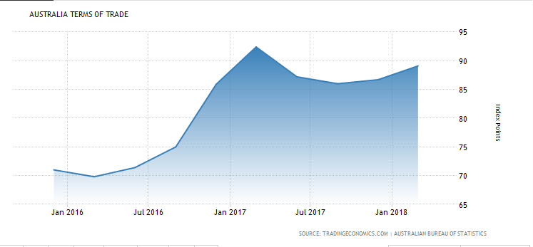
- Identify and explain one possible cause of the trend in Australia’s terms of trade over the last two years.
2 marks
One possible cause of the favourable trend in the terms of trade over the last two years is higher commodity prices caused by an increase in the global demand of Australia main exports. This increase in global demand (of which a large percentage was China), put upward pressure on commodity prices, increasing the average price of Australia’s exports relative to the average price of Australia’s imports, leading to a favourable movement of the terms of trade.

- Explain how the trend in the terms of trade over the last two years would impact the following:
4 marks

The value of the $AUD
A favourable movement of the terms of trade means that the average price Australia receives for its exports is greater than the average prices Australians pay for imports. Ceteris paribus, this would lead to a greater level of export revenue relative to import expenditure, and there would therefore be an increase in the demand for the $AUD, and a relative decrease in supply of the $AUD, appreciating the value of the exchange rate.

Economic growth
The favourable movement in the terms of trade means the average price of exports has increased relative to the average price of imports. Given the low PED of Australia’s main exports (as commodities have a high degree of necessity) it means that higher average prices will increase export revenue (X) relative to import expenditure (X), increasing net exports (X-M). This will increase aggregate demand in the economy and lead to a higher level of national output from firms, increasing real GDP and therefore economic growth in Australia.
Question 4
- Explain the impact that trade liberalisation could have on the following:
6 marks
- Structural unemployment
Trade liberalisation means the reduction of trade protection, which leads to an increase in competition from overseas producers which will force domestic firms to increase technical efficiency and adopt ‘world’s best practice’ in the production of goods and services in order to remain competitive. In the process of increasing technical efficiency and productivity it might mean the replacement of labour with capital, or a change in location to an area where wages are lower in order to cut production costs. This will lead to labour being made redundant and lead ot an increase in structural unemployment.
Note: or the argument could be that some firms would cease operations as a result of overseas competition.
- Cyclical unemployment
Overtime, the improvements in technical efficiency and productivity that Australian firms realise as a result of trade liberalisation will lead to an increase in the productive capacity of the Australia economy, increasing aggregate supply and the ability of the Austrlain economy to icrease AD and real GDP in the long term without any inflationary pressure. Over time, this non-inflationary economic growth will increase the demand for labour resources in the Australian economy, decreasing cyclical unemployment.

- The inflation rate
The aforementioned improvements in technical efficiency and productivity that come from an economy liberalising trade and adopting ‘world’s best practice’ in production techniques should see firms’ average costs of production fall, while increasing their ability to supply goods and services (increasing AS). This increase in productive capacity coupled with lower costs of production will put downward pressure on cost inflation as producers will pass on these lower costs to consumers in the form of lower prices for their goods and services.

Question 5

- Analyse the relationship between the exchange rate and the current account balance.
4 marks
A change in the value of the exchange rate will change the current account balance, while a change in the current account balance will in turn also change the value of the $AUD.

A deprecation of the exchange rate will lead to Australia’s exports being cheaper to foreign consumers, increasing the demand for exports and increasing the value of credits in the net goods and services section of the current account. Moreover, the depreciation will make imports more expensive to Australian consumers, decreasing demand for imports and therefore decreasing the value of debits in the balance of goods and services, increasing the current account surplus that Australia currently has. An appreciation would have the oppositive effect and lead to more debits from import spending and less credits from export revenue.

The current account balance will also impact the value of the exchange rate. For example, an increase in credits in the current account from export revenue in the balance of merchandise trade will also lead to an increase in the demand for the $AUD, appreciating its value, while an increase in debits from higher import expenditure will increase the supply of the $AUD, depreciating its value.

